./

GENESIS - Learning Outcome & Mini-project Summary Report



|  |  |  |  |  |  |
| --- | --- | --- | --- | --- | --- |
| **Ver. Rel. No.** | **Release Date** | **Prepared. By** | **Reviewed By** | **To be Approved** | **Remarks/Revision Details** |
| 1 |  | Vinay Kumar |  |  | Requirements |
| 2 |  | Pavan S L |  |  | Design |
| 3 |  | Afrid Shariff |  |  | Test Plan |

Table of Contents

Miniproject -2 JavaScript Jasmine and HTML [Team] 6

**Modules** 6

Topic and Subtopics 6

**Objectives & Requirements** 6

**Requirements:** 6

High level 6

Low level 6

**Design**: 7

Structural diagram: 7

**Behavioral diagram:** 8

**Test** Plan 9

**Implementation** **Summary** 11

**Git Link:** LINK 11

Git Dashboard 12

GIT Summary: 12

**Video Summary** 13

Video link: Git Link 13

Summary 13

Individual Contribution & Highlights 13

Future Scope: 13

List of Figures

Figure 1 Structural class diagram 7

Figure 2 Behavioral flow chart 8

Figure 3 GitHub Dashboard 12

List of Tables

Table 1 High Level Requirement Analysis for Calculator application 6

Table 2 Low Level Requirement analysis for Calculator application 7

Table 3 Test Plan for Calculator 11

# Miniproject -2 JavaScript Jasmine and HTML [Team]

## **Modules**

1. Modules linked to project: JavaScript and Jasmine. JavaScript is used for building and styling of web pages.
2. Jasmine is used for testing the built web page.

### Topic and Subtopics

1. Basic tags, CSS, different attributes and their usage in styling, viewing the content in default browser.
2. For testing different functions used in web page, Jasmine framework is used.
3. Describing a test suite, Spec file creation. Writing test cases in Jasmine.

## **Objectives & Requirements**

1. Creation of user interactive Calculator in web page and performing arithmetic functions.
2. Testing the created Calculator page using Jasmine framework.

## **Requirements:**

### High level

|  |  |
| --- | --- |
| **ID** | **Description** |
| HL_01 | Android Studio Code to perform programming. |
| HL_02 | Launch the Chrome browser to display webpage. |
| HL_03 | User Inputs |
| HL_04 | Operation buttons |
| HL_05 | Display bar to display the result. |

Table High Level Requirement Analysis for Calculator application

### Low level

|  |  |
| --- | --- |
| **ID** | **Description** |
| HL_LL_02_01 | Open a Calculator webpage in chrome. |
| HL_LL_03_01 | User input_1 |
| HL_LL_03_02 | User input_2 |
| HL_LL_04_01 | Arithmetic Operations (+, _, *, /) |
| HL_LL_04_02 | Clear button to clear the inputs |
| HL_LL_04_03 | Operations (Sqrt and %) |

Table Low Level Requirement analysis for Calculator application

## **Design**:

### Structural diagram:

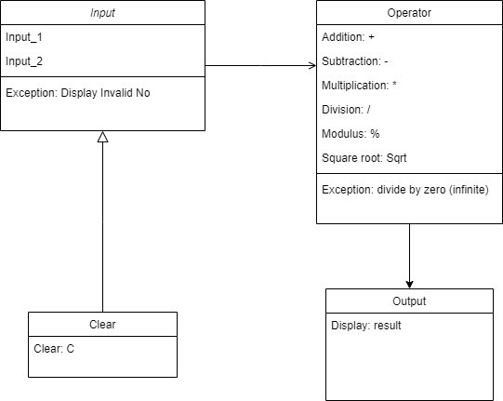

Figure Structural class diagram

## **Behavioral diagram:**

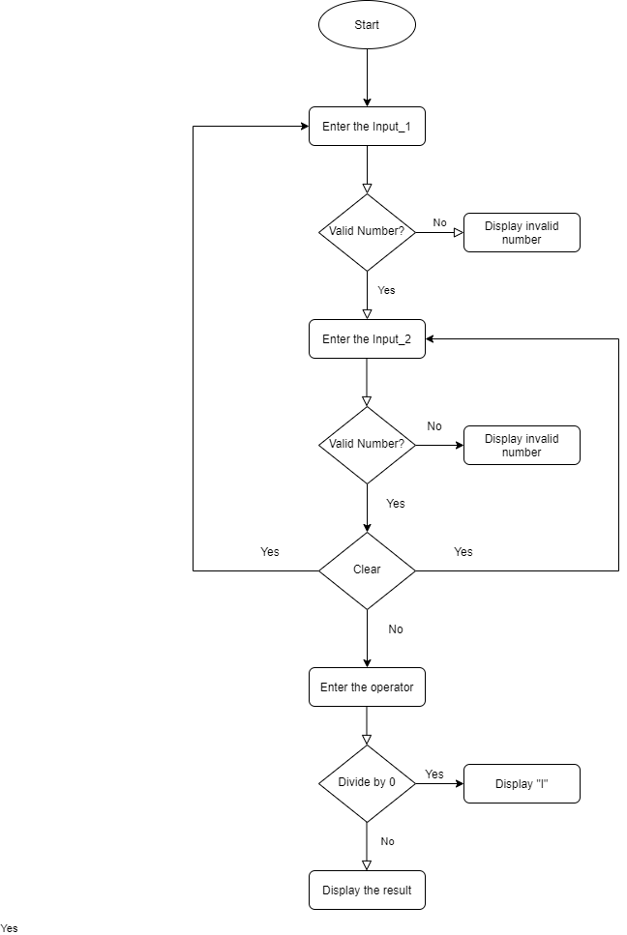

Figure Behavioral flow chart

## **Test** Plan

| **No.** | **Test Case -ID** | **Test case Objective** | **Prerequisite** | **Steps** | **Input data** | **Expect ed Result** | **Actual Result** | **Re marks/Status** |
| --- | --- | --- | --- | --- | --- | --- | --- | --- |
| 1 | TC1 | To add two integer and display the result on calculator | Calculator App is launched | 1.First Operand a valid integer 2.second operand, a valid integer  3. operator + | 135 + 100 | 235(addition, above twenty-one digits will be expressed in exponential form) | 235 | Pass |
| 2 | TC-2 | To subtract two integer and display the result on calculator | Calculator App is launched | 1.First Operand a valid integer 2. second operand, a valid integer  3. operator - | 135- 100 | 35(abstraction n,above twenty-one digits will be expressed in exponential form) | 35 | Pass |
| 3. | TC-3 | To multiply two integer and display the result on calculator | Calculator App is launched | 1.First Operand a valid integer 2. second operand, a valid integer  3. operator x | 100 x 400 | 40000(multi plication, above twenty-one digits will be expressed in exponential form) | 40000 | Pass |
| 4. | TC4 | To divide two integer and display the result on calculator | Calculator App is launched | 1.First Operand a valid integer 2. second operand, a valid integer  3. operator / | 100/ 25 | 40 | 40 | Pass |
| 5 | TC5 | To clear the screen | Calculator App is launched | Press C |  | Input1 and Input2 Fields should be cleared and placeholder should display | Input1 and Input2 Fields are cleared and placeholder are displayed | Pass |
| 6 | TC6 | To Find a Square-root of a number | Calculator App is launched | 1.Operand a valid integer  2. Operator Sqrt | 25 | 5 | 5 | Pass |
| 7 | TC7 | To Find a Modulo of a given numbers | Calculator App is launched | 1. First Operand a valid integer 2. second operand, a valid integer  3. operator % | 5%6 | 5 | 5 | Pass |
| 8 | TC7 | To check for NaN(Not a number) | Calculator App is launched | Any one or both of the operands are empty |  | NaN | NaN | Pass |

Table Test Plan for Calculator

## **Implementation** **Summary**

JavaScript is used for building web pages .Different basic tags and styling tags were used to design the web page. Functions for performing different arithmetic operations are written in .js files and are included using script tags in HTML pages. An user interactive calculator is developed using JavaScript. Testing functions are written in .js file and test cases are written in Spec file. All the files are included in Spec Runner.HTML file and executed in default browser to view the test cases validation.

1. GitHub user - **99002562** as a contributor to the repo
2. GitHub user - **99002690** as a contributor to the repo
3. GitHub user - **99002675** as a contributor to the repo

## **Git Link:** [LINK](https://github.com/99002675/2009MYSEMB03-JavaScript-Jasmine-MiniProject-Team-08.git)

### Git Dashboard

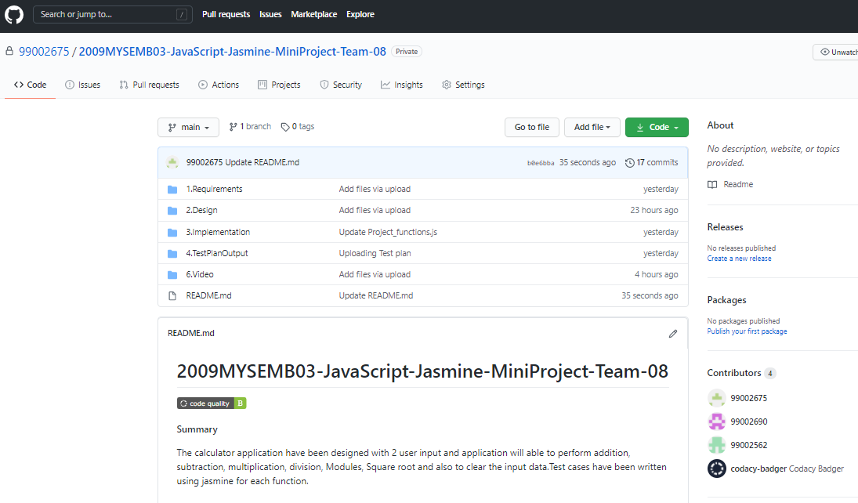

Figure GitHub Dashboard

GIT Summary:

The GitHub repository has the following files which explains documentation of the project:

1. Requirements: This contains the high level and low-level requirements of the project

2. Architecture: This contains the necessary UML diagrams present in the project

3.  Implementation: This contains the source code of the following project (HTML, CSS, JavaScript,

Jasmine, and Selenium).

4. Test Plan and output: This contains the test plan and the obtained outputs of the project

5.  Report: This contains the report of the project

6.  Images and videos: This contains the images and the working of project

## **Video Summary**

Team Members: Afrid Shariff, Pavan SL, Vinay Kumar V

### Video link: Git [Link](https://github.com/99002675/2009MYSEMB03-JavaScript-Jasmine-MiniProject-Team-08/tree/main/6.Video)

# Summary

The calculator application have been designed with 2 user input and application will able to perform addition, subtraction, multiplication, division, Modules, Square root and also to clear the input data.Test cases have been written using jasmine for each function.

#### Code quality and Issues or Bug Tracking

Code quality is done for source code and ‘B’ badge is obtained.Issues related to certain functions were raised and those were solved by the teammates actively.

#### Unit Testing

The individual functions/modules used in our project are tested using Jasmine framework.

# Individual Contribution & Highlights

Web page was developed by Pavan SL and Afrid.

Jasmine Testing of operations/functions was done by Vinay.

Requirement Analysis was done by Vinay, Design was done by Pavan, Test Plan was done by Afrid.

Most of the work related to documentation and GitHub were done as a team.

# Future Scope:

Fallowing feature can be included to enhance the functionality

* Functions can be written to perform more mathematical and trigonometrical operations.
* Further new operations can be implemented so as to make this a scientific calculator.